Sri Lanka Institute of Information

Technology



Lab Submission

Lab Sheet 05

**IT24104309**

**Wickramanayake P. T.**

**Probability and Statistics | IT2120**

B.Sc. (Hons) in Information Technology

**Question 01: Import the dataset (’Exercise – Lab 05.txt’) into R and store it in a data frame called “DeliveryTimes”.**

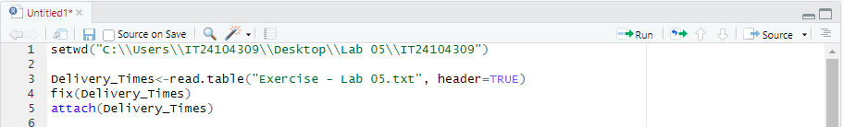  


**Question 02: Draw a histogram for** **deliver times using nine class intervals where the lower limit is 20 and upper limit is 70. Use right open intervals.**  
  


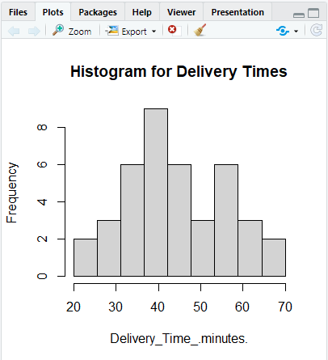

**Question 03: Comment on the shape of the distribution.**

The Histogram has a single high peak. Therefore, it is unimodal.

The long tail of the distribution extends to the right. Therefore, it is Skewed Right/Positively Skewed.

**Question 04: Draw a cumulative frequency polygon (ogive) for the data in a separate plot.**

